Diversity Statement

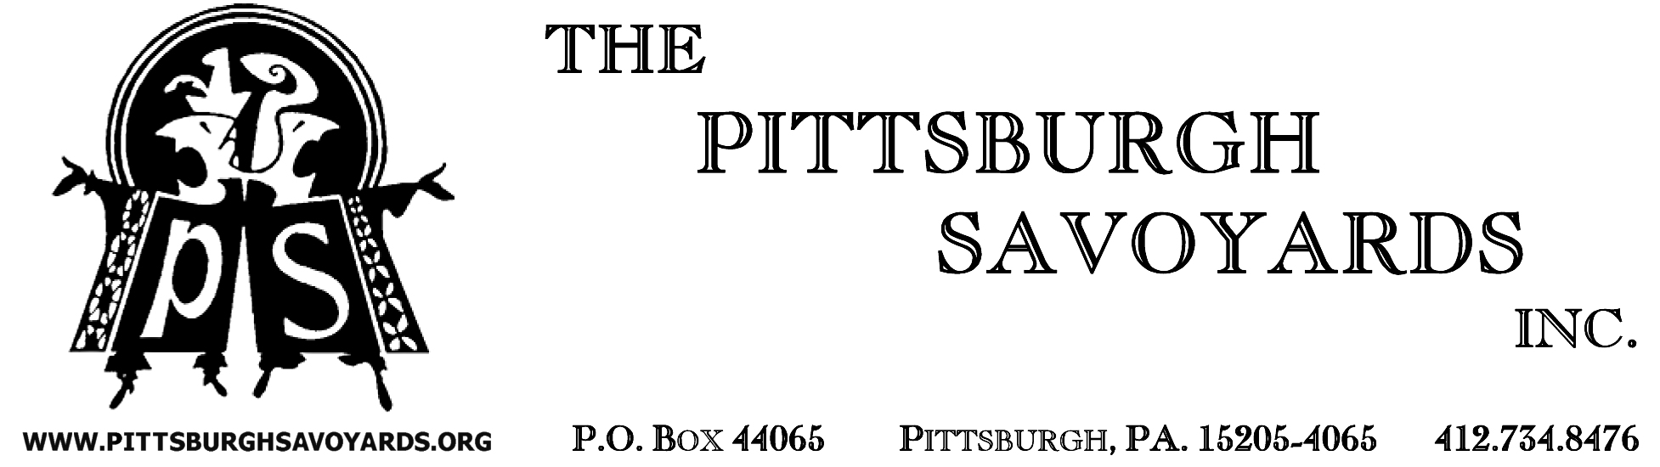

The Pittsburgh Savoyards is a semi-professional, cultural, performing arts organization, specializing in the performance of works of light comic opera in the Greater Pittsburgh area by, and for, all peoples of the area and does not discriminate on the basis of age, gender identity, religious identity, physical abilities, socio-economic status, sexual orientation, ethnicity, race, cultural heritage, cultural identity or international origin.

We provide timely access to information about employment and volunteer opportunities to people in the areas we serve by:

- Posting such notifications on our website.
- Advertising postings online and on targeted public groups & listings.
- Contacting schools and agencies requesting referrals for employment and volunteer positions for diverse populations in the area, and posting in as many public bulletin board posting spaces as possible with volunteer staff, canvassing libraries, schools and other community organizations.
We provide timely access to information about performances to people in the areas we serve by:

- Posting such notifications on our website.
- Advertising postings online and on targeted public groups & listings.
- Contacting schools, agencies and communities in the area for referrals of new and diverse target audiences for performances and offering free or discounted admission to events to groups who have economic hardship gaining access to our type of cultural events.
- Distributing and posting flyers and posters for performances as far and wide to area bulletin boards in as many and diverse area communities as possible with volunteer staff, canvassing libraries, schools and other community organizations.
We endeavor to be as inclusive as possible in appointing people of diverse backgrounds to both our governing and advisory boards and to all committees formed to help us accomplish our goals and work. We seek out referrals from other organizations to help fulfill these needs.

